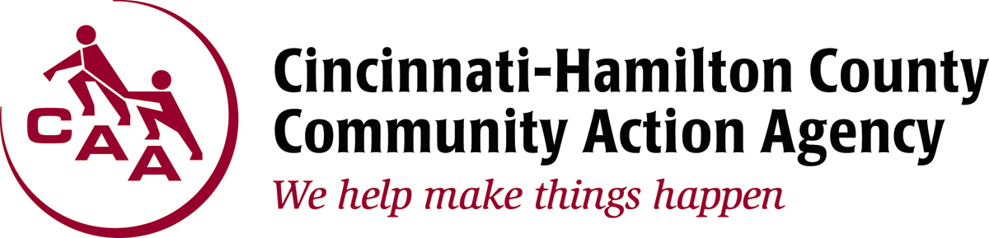

1740 Langdon Farm Road Cincinnati, OH 45237

PRESS RELEASE: April 28, 2016 CONTACT: Randi Kamp
Office: 513.569.1853
Cell: 859-466-8714
rkamp@cincy-caa.org

Assistance Available For Energy Bills
The long winter has been a drain on household budgets and many families are already seeing the high temperatures affect their summer cooling bills. Some Ohio residents may be eligible for financial relief and able to reduce their monthly utility bill payments through the Percentage of Income Payment Plan (PIPP Plus).

PIPP Plus allows eligible households to maintain gas and electric services by paying a percentage of their household income, regardless of monthly usage. The program is a year-round payment plan that eliminates old utility debt when payments are made on time and in-full, essentially freeing the customer of old utility debt in 2 years.

Eligible PIPP Plus applicants must earn a household income at or below 150% of the Federal Poverty Guidelines. The following are required when applying: current utility bill, proof of income for all household members for the past 90 days, a photo ID and social security cards for all household members.

Hamilton County residents may apply for PIPP Plus at the Cincinnati-Hamilton County Community Action Agency (CAA), 1740 Langdon Farm Road, Cincinnati 45237. All appointments are scheduled weekdays through our automated appointment line at 513-569-1850. Applications may also be obtained at your local library or CAA and mailed, with all required documentation, to the Ohio Office of Community Services. For more information, call toll free 1-800-282-0880 or visit www.cincy-caa.org.

###

