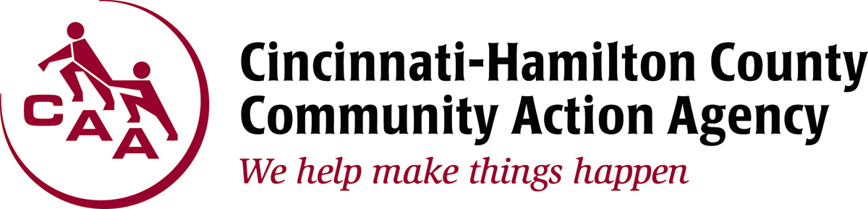

1740 Langdon Farm Road Cincinnati, OH 45237

For Immediate Release: CONTACT: Randi Kamp
January 30, 2017 Office: 513.569.1853
Cell: 859.466.8714
rkamp@cincy-caa.org

Heating Assistance Available
Winter Crisis Program Runs through March 31

(Cincinnati, OH) – The Cincinnati-Hamilton County Community Action Agency (CAA) HEAP Winter Crisis Program is in full swing and will run through March 31, 2017. Since its launch in November, HEAP staff have assisted more than 4,000 eligible clients who have been threatened with disconnection due to high energy bills.

Qualifying for HEAP is dependent upon the size of the household and the total gross household income for either the past three or 12 months. For the Winter Crisis Program the gross income of eligible households must be at or below 175 percent of the federal poverty guidelines. For a family of four the annual income must be at or below $42,437.50.

Those wanting to schedule an appointment for emergency assistance are able to call the hotline at (513) 569-1850 and press option 2 to make a same-day appointment. Calls are taken from 9 a.m. until 11 a.m. Monday through Thursday in order to receive a walk-in timeslot on that same day between 1 p.m. and 3 p.m. Assistance is also available through CAA outreach sites including St. Vincent de Paul Winton Terrace, Churches Active in Northside and Freestore Foodbank.
Candidates must present the following required documents:
(All documentation is required each time you apply for services)
• Valid Picture ID for Applicant; (Includes all individuals listed on utility bill and those applying on applicant’s behalf. Current notarized letter is also required for individuals’ applying on applicant’s behalf);
• Current Duke Energy Utility Bill (actual bill only, no door hangers.) CANNOT be finalized bill, if moving;
• Social Security Cards for all household members (must have the actual card or printout);
• 90 days of income. If you are paid bi-weekly seven (7) stubs are needed; weekly thirteen (13) stubs are needed.

HEAP’s programs are designed to assist Hamilton County residents with their utility bills and are federally-funded and administered across the state by the Ohio Department of Development. For more information on HEAP or any of the programs offered by CAA, please visit www.cincy-caa.org.

###

