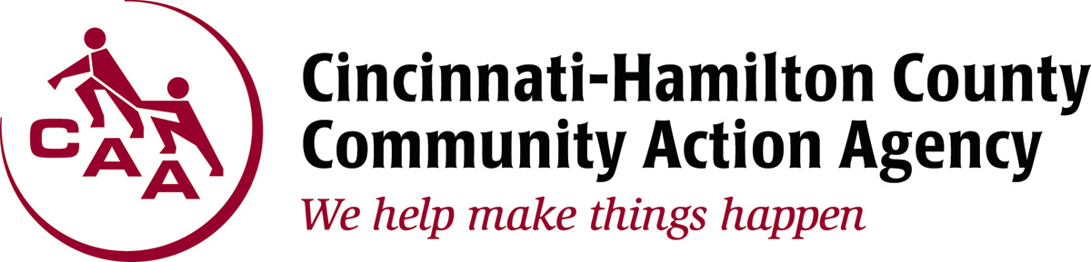

1740 Langdon Farm Road Cincinnati, OH 45237

For Immediate Release: CONTACT: Randi Kamp
February 29, 2017 Office: 513.569.1853
Cell: 859.466.8714
rkamp@cincy-caa.org

DEADLINE APPROACHING FOR CAA WINTER CRISIS PROGRAM

(Cincinnati, OH) – Cincinnati-Hamilton County Community Action Agency (CAA) is entering the final weeks of the Winter Crisis Program. The program, a component of the Home Energy Assistance Program (HEAP), provides assistance to eligible households threatened with disconnection.

Those wanting to schedule an appointment for emergency assistance are able to call the hotline at (513) 569-1850 and press option 2 to make a same-day appointment. Calls are taken from 9 a.m. until 11 a.m. Monday through Thursday in order to receive a walk-in timeslot on that same day between 1 p.m. and 3 p.m. Assistance is also available through CAA outreach sites including St. Vincent de Paul Winton Terrace, Churches Active in Northside and Freestore Foodbank. The deadline to receive assistance is March 31.

To be eligible, families must reside in Hamilton County, earn a household income at or below 175 percent of the Federal Poverty Income Guidelines, and provide the following documentation:

• Valid Picture ID for Applicant; (Includes all individuals listed on utility bill and those applying on applicant’s behalf. Current notarized letter is also required for individuals’ applying on applicant’s behalf);
• Current Duke Energy Utility Bill (actual bill only, no door hangers.) CANNOT be finalized bill, if moving;
• Social Security Cards for all household members (must have the actual card or printout);
• 90 days of income. If you are paid bi-weekly seven (7) stubs are needed; weekly thirteen (13) stubs are needed.

HEAP’s program is designed to assist Hamilton County residents with their utility bills and is
federally-funded and administered across the state by the Ohio Department of Development.
For more information on HEAP or any of the programs offered by CAA, please visit
www.cincy-caa.org.
###

